**URDF KNEE**

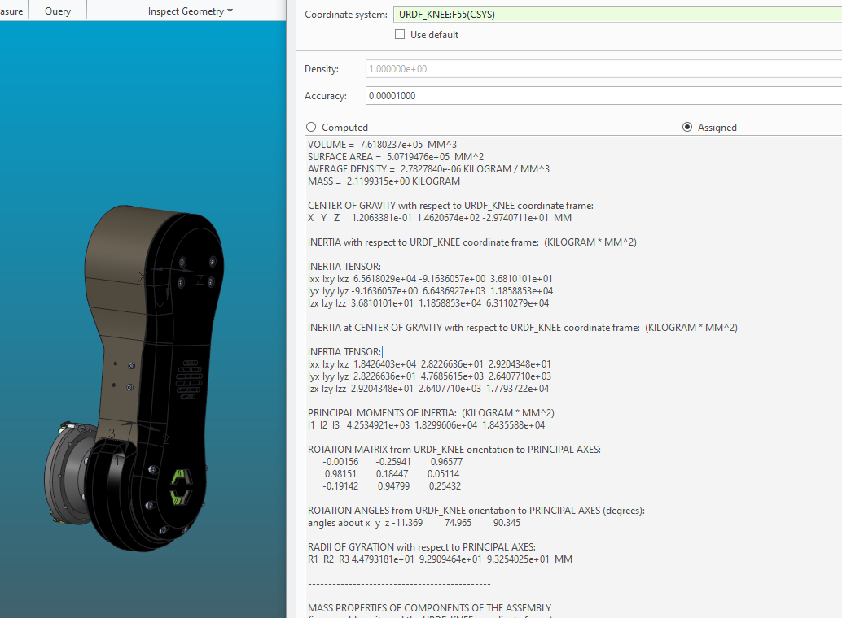

VOLUME = 7.6180237e+05 MM^3

SURFACE AREA = 5.0719476e+05 MM^2

AVERAGE DENSITY = 2.7827840e-06 KILOGRAM / MM^3

MASS = 2.1199315e+00 KILOGRAM

CENTER OF GRAVITY with respect to URDF_KNEE coordinate frame:

X Y Z 1.2063381e-01 1.4620674e+02 -2.9740711e+01 MM

INERTIA with respect to URDF_KNEE coordinate frame: (KILOGRAM * MM^2)

INERTIA TENSOR:

Ixx Ixy Ixz 6.5618029e+04 -9.1636057e+00 3.6810101e+01

Iyx Iyy Iyz -9.1636057e+00 6.6436927e+03 1.1858853e+04

Izx Izy Izz 3.6810101e+01 1.1858853e+04 6.3110279e+04

INERTIA at CENTER OF GRAVITY with respect to URDF_KNEE coordinate frame: (KILOGRAM * MM^2)

INERTIA TENSOR:

Ixx Ixy Ixz 1.8426403e+04 2.8226636e+01 2.9204348e+01

Iyx Iyy Iyz 2.8226636e+01 4.7685615e+03 2.6407710e+03

Izx Izy Izz 2.9204348e+01 2.6407710e+03 1.7793722e+04

PRINCIPAL MOMENTS OF INERTIA: (KILOGRAM * MM^2)

I1 I2 I3 4.2534921e+03 1.8299606e+04 1.8435588e+04

ROTATION MATRIX from URDF_KNEE orientation to PRINCIPAL AXES:

-0.00156 -0.25941 0.96577

0.98151 0.18447 0.05114

-0.19142 0.94799 0.25432

ROTATION ANGLES from URDF_KNEE orientation to PRINCIPAL AXES (degrees):

angles about x y z -11.369 74.965 90.345

RADII OF GYRATION with respect to PRINCIPAL AXES:

R1 R2 R3 4.4793181e+01 9.2909464e+01 9.3254025e+01 MM

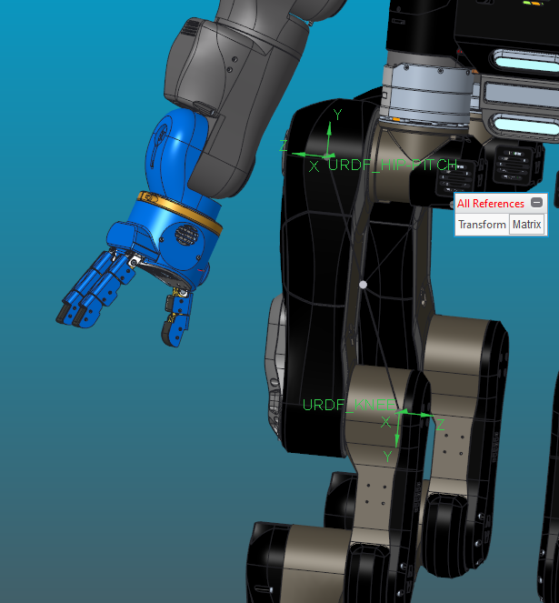

1.00000 0.0000000000 0.0000000000 0.0000000000

0.0000000000 -1.00000 0.0000000000 -300.000

0.0000000000 0.0000000000 -1.00000 -118.200